**CHANDIGARH UNIVERSITY**

**UNIVERSITY INSTITUTE OF ENGINEERING**

**DEPARTMENT OF COMPUTER SCIENCE & ENGINEERING**



|  |  |
| --- | --- |
| **Submitted By:** Sahil Kaundal  **Submitted To:** Neha Dutta | |
| **Subject Name** | Design and Analysis of Algorithm Lab |
| **Subject Code** | 20CSP-312 |
| **Branch** | Computer Science Engineering |
| **Semester** | 5th |

**Experiment 9**

**Student Name:** Sahil Kaundal **UID:** 21BCS8197

**Branch:** BE CSE (Lateral Entry) **Section/Group:** 616/A

**Semester:** 5th **Date of Performance:** 10/11/2022

**Subject Name:** DAA Lab **Subject Code:** 21-CSP-312

# Aim/Overview of the practical:

Code and analyze to find shortest paths in a graph with positive edge weights using Dijkstra’s algorithm.

# Task to be done/ Which logistics used:

Code and analyze to find shortest paths in a graph with positive edge weights using Dijkstra’s algorithm.

# Requirements:

Laptop or PC.

Operation system (Mac, Windows, Linux, or any)

Vs-Code with MinGw or any C++ Compiler

1. **Algorithm/Flowchart (For programming-based labs):**

* Create a set sptSet (shortest path tree set) that keeps track of vertices included in the shortest- path tree, i.e., whose minimum distance from the source is calculated and finalized. Initially, this set is empty.
* Assign a distance value to all vertices in the input graph. Initialize all distance values as INFINITE. Assign the distance value as 0 for the source vertex so that it is picked first.
* While sptSet doesn’t include all vertices
* Pick a vertex u which is not there in sptSet and has a minimum distance value.
* Include u to sptSet.
* Then update distance value of all adjacent vertices of u.
* To update the distance values, iterate through all adjacent vertices.
* For every adjacent vertex v, if the sum of the distance value of u (from source) and weight of edge u-v, is less than the distance value of v, then update the distance value of v.

# Steps for experiment/practical/Code:

#include <bits/stdc++.h> using namespace std;

vector<int> dijkstra(vector<vector<int>>&vec, int vertices, int edges, int source)

{

unordered_map<int, list<pair<int, int>>> adj; for (int i = 0; i < edges; i++)

{

int u = vec[i][0];

int v = vec[i][1]; int dist = vec[i][2];

// pair<int,int> p1 = make_pair(u,dist),p2=make_pair(v,dist); adj[u].push_back(make_pair(v, dist)); adj[v].push_back(make_pair(u, dist));

}

vector<int> dist(vertices, INT_MAX); set<pair<int, int>> st;

dist[source] = 0; st.insert(make_pair(0, source)); while (!st.empty())

{

// fetch top record

auto top = *(st.begin()); int nodeDist = top.first; int node = top.second;

// delete top st.erase(st.begin());

// traverse the adj

for (auto it : adj[node])

{

if (nodeDist + it.second < dist[it.first])

{

auto record = st.find(make_pair(dist[it.first], it.first)); if (record != st.end())

st.erase(record);

// distance update

dist[it.first] = nodeDist + it.second;

// insert value in set st.insert(make_pair(dist[it.first], it.first));

}

}

}

return dist;

}

int main()

{

int n, e;

// Undirected Graph cout <<"No of nodes: "; cin >> n;

cout <<"No of edges: "; cin >> e;

vector<vector<int>> edges; for (int i = 0; i < e; i++)

{

int u, v, wt; cin >> u; cin >> v; cin >> wt;

edges.push_back({u, v, wt});

}

vector<int> distance = dijkstra(edges, n, edges.size(), 0);

for (int i = 0; i < n; i++)

{

cout <<"Shortest distance from 0 to "<< i <<": "<< distance[i] <<

endl;

}

return 0;

}

# Result/Output/Writing Summary:

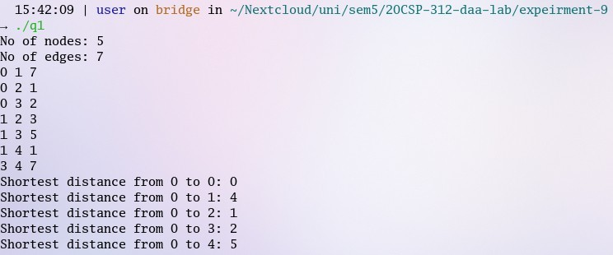

**Learning outcomes (What I have learnt):**

* Use of Dijkstra’s algorithm
* Implementing Dijkstra’s algorithm

**Evaluation Grid (To be created as per the SOP and Assessment guidelines by the faculty):**

|  |  |  |  |
| --- | --- | --- | --- |
| Sr. No. | Parameters | Marks Obtained | Maximum Marks |
| 1. |  |  |  |
| 2. |  |  |  |
| 3. |  |  |  |